**Handlin Nulls:**

Handled, but actual data have nulls so I had to remove some of the returned predicted to adjust the length of both to be equal.

**Column “anomaly”**

Not handled correctly

**Lag problem:**

We have problems with 4 datasets, their lag is larger than the size of the data set itself

Dataset id = 119, size of data = 20, lag length = 22

Dataset id = 301, size of data = 20, lag length = 22

Dataset id = 397, size of data = 56, lag length = 66

Dataset id = 430, size of data = 47, lag length = 52

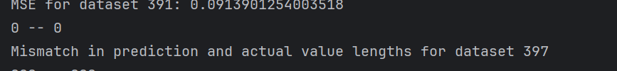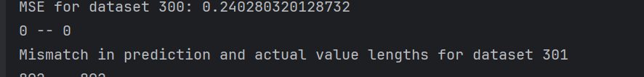

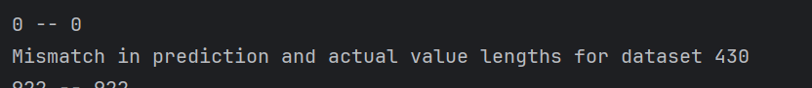

So we only end up with 92 dataset being sent to the API